# **AWS lab :**

# 

# **AWS RDS Multi AZ Failover**

Reference : https://youtu.be/Mu7fgHOzOn0?si=dkocQQS9-DXeA4fH

Step 1 : login to aws management console and navigate to VPC dashboard.

Step 2: create a VPC having 3 subnets : 2 private subnet and 1 public subnet .please make sure private subnet should be in different region

Step 3: create 2 route tables : one for private subnets and one for public subnet.associate both the private subnets to private route table and public subnet to public route table.

Step 4: create an internet gateway,attach to your VPC and add its route to the public route table.

Step 5: now navigate to the RDS console and go to subnet groups .Click on “create DB subnet group” .

Step 6: after click on create subnet group:

* Name the subnet group
* Give the short description to it
* Select the VPC that you create in step 2
* Select those availability zones in which your private subnets are created.
* Select both the private subnets.
* Then click on “create”

Step 7: Move to ec2 dashboard and create a security group for your rds. Add two inbound rules: SSH and MYSQL/Aurora.

For ssh, select the source “anywhere”

For MYSQL, select the source “custom” and paste your VPC ipv4 address.

Step 8: Now click on “databases” in the RDS console and click on “create database”.

Step 9: to create the database :

* Selectbthe “standard create” creation method.
* Select the “MYSQL” engine options.
* Select the “dev/Test” templates
* Select the availability and durability configuration as “Multi-AZ DB instance” .
* Name the DB instance identifier, e.g., myRDSdb
* Configure the master username and master password.You can change the master username but we take it by default i.e.,admin.
* Select the “burstable classes(include t class)” db instance class.
* Configure the storage settings: such as storage type and allocated storage .we take it by default.
* Configure the 'connectivity settings' ' :select the “don’t connect to an ec2 compute resource” ,and your VPC,disable the public access,select the created security group(created in step 7) in the existing VPC security group.
* In database options,give the initial database name.
* Keep all the settings by default and then click on “create database”.it will take around 5-10 minutes to completely create the database.

Step 10: go to ec2 dashboard and create and launch an ec2 linux instance in the public subnet of your VPC and enable public ip and use the same ec2 security group used in RDS database.

Step 11:now take the ssh of your ec2 instance and run the following commands:-

* First after login to ec2 linux session,install the mysql :

**sudo yum install mysql -y**

* Now ,connect the mysql with your RDS database using its endpoint.copy your database endpoint and paste it into following command:

**mysql -h “RDS database end-point” -u admin -p**

Note: If above command now work then try to run this command: mysql -h “rds db endpoint” -u “master username” -p 3306 -p

* Then enter your ,master password (assigned at the time of database creation)

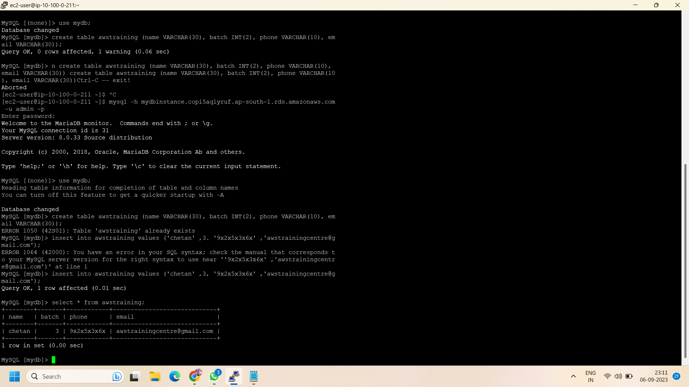

Step 12:after following the above commands ,a mysql dashboard will open .apply the following commands to create a “aws training” database using sql queries:

**>show database ;**

**>use mydb ;**

**>create table awstraining (name VARCHAR(30), batch INT(2), phone VARCHAR(10), email VARCHAR(30)) ;**

**>insert into awstraining values (‘Aayush Mishra’ , 8, ‘9x2x6x3x2x’,**

**’awstrainingcentre@gmail.com’);**

**>select * from awstraining ;**

Step 13: now exit from mysql session and copy the following command in ec2 host:

**While true; do host “your RDS instance endpoint” ; sleep 3; done**

It will show you your current availability zone and in case of any failover it will change its availability zone by its own.For example before failover,our RDS database is in ap-south-1a and ip address is 10.100.1.73

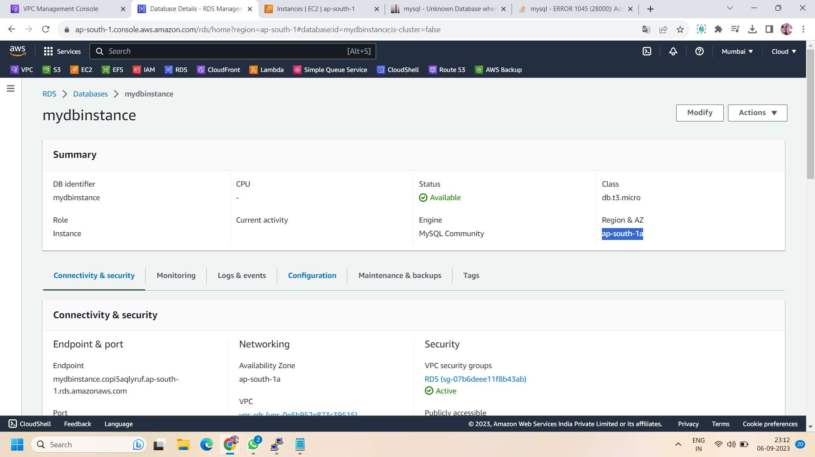

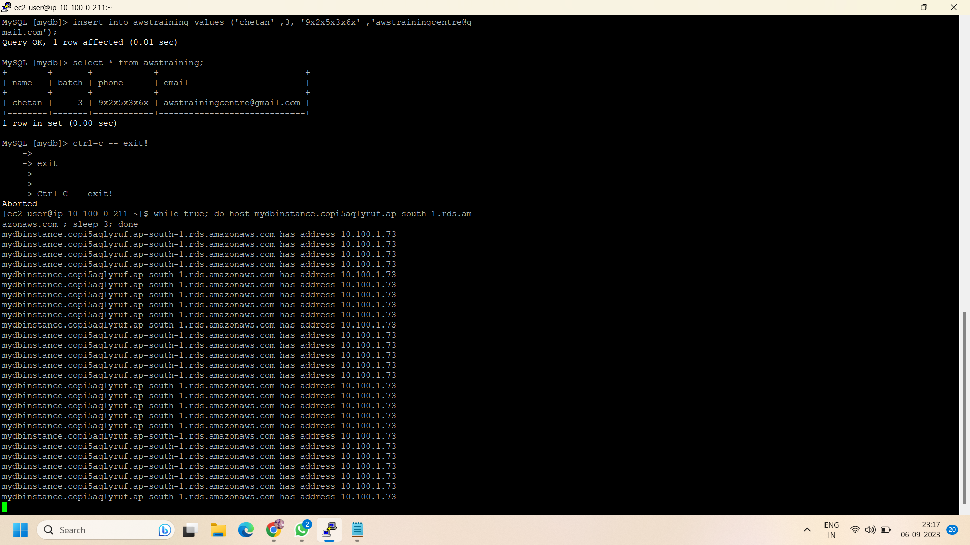

Step 14: After creating the database table ,now go to RDS database console and select your database and click on actions and select the “reboot” option and click on “reboot with failover”and then click on “reboot”.

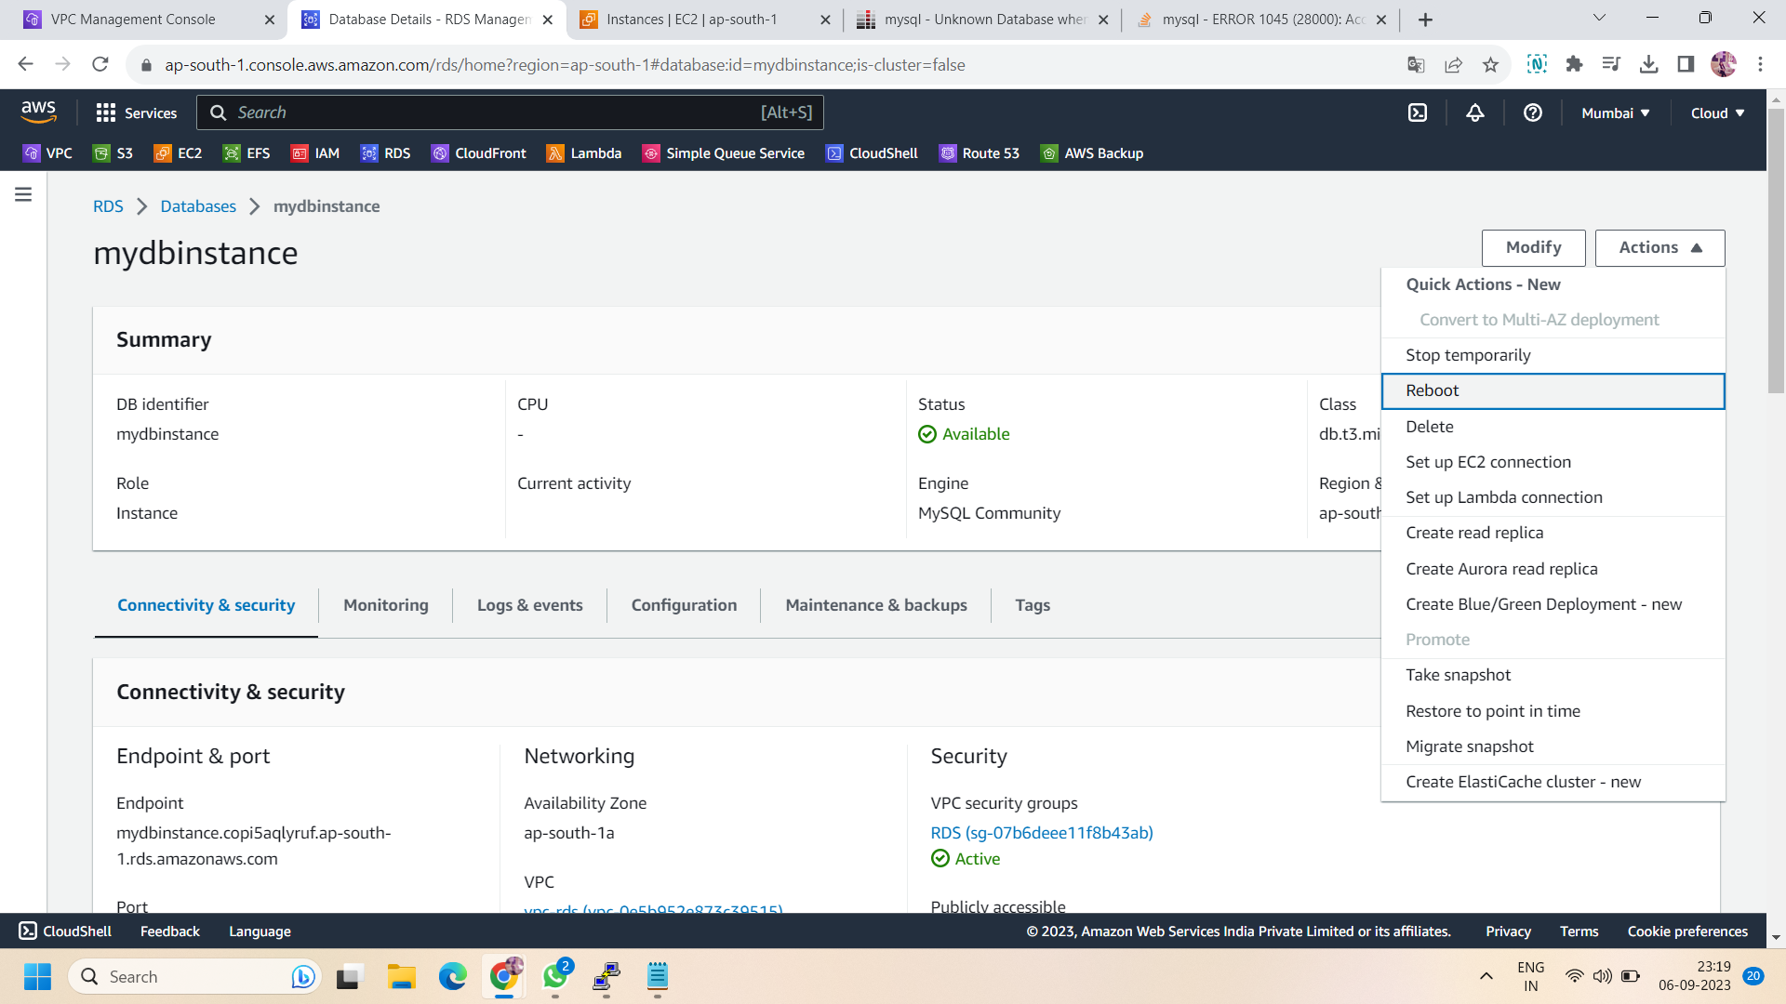

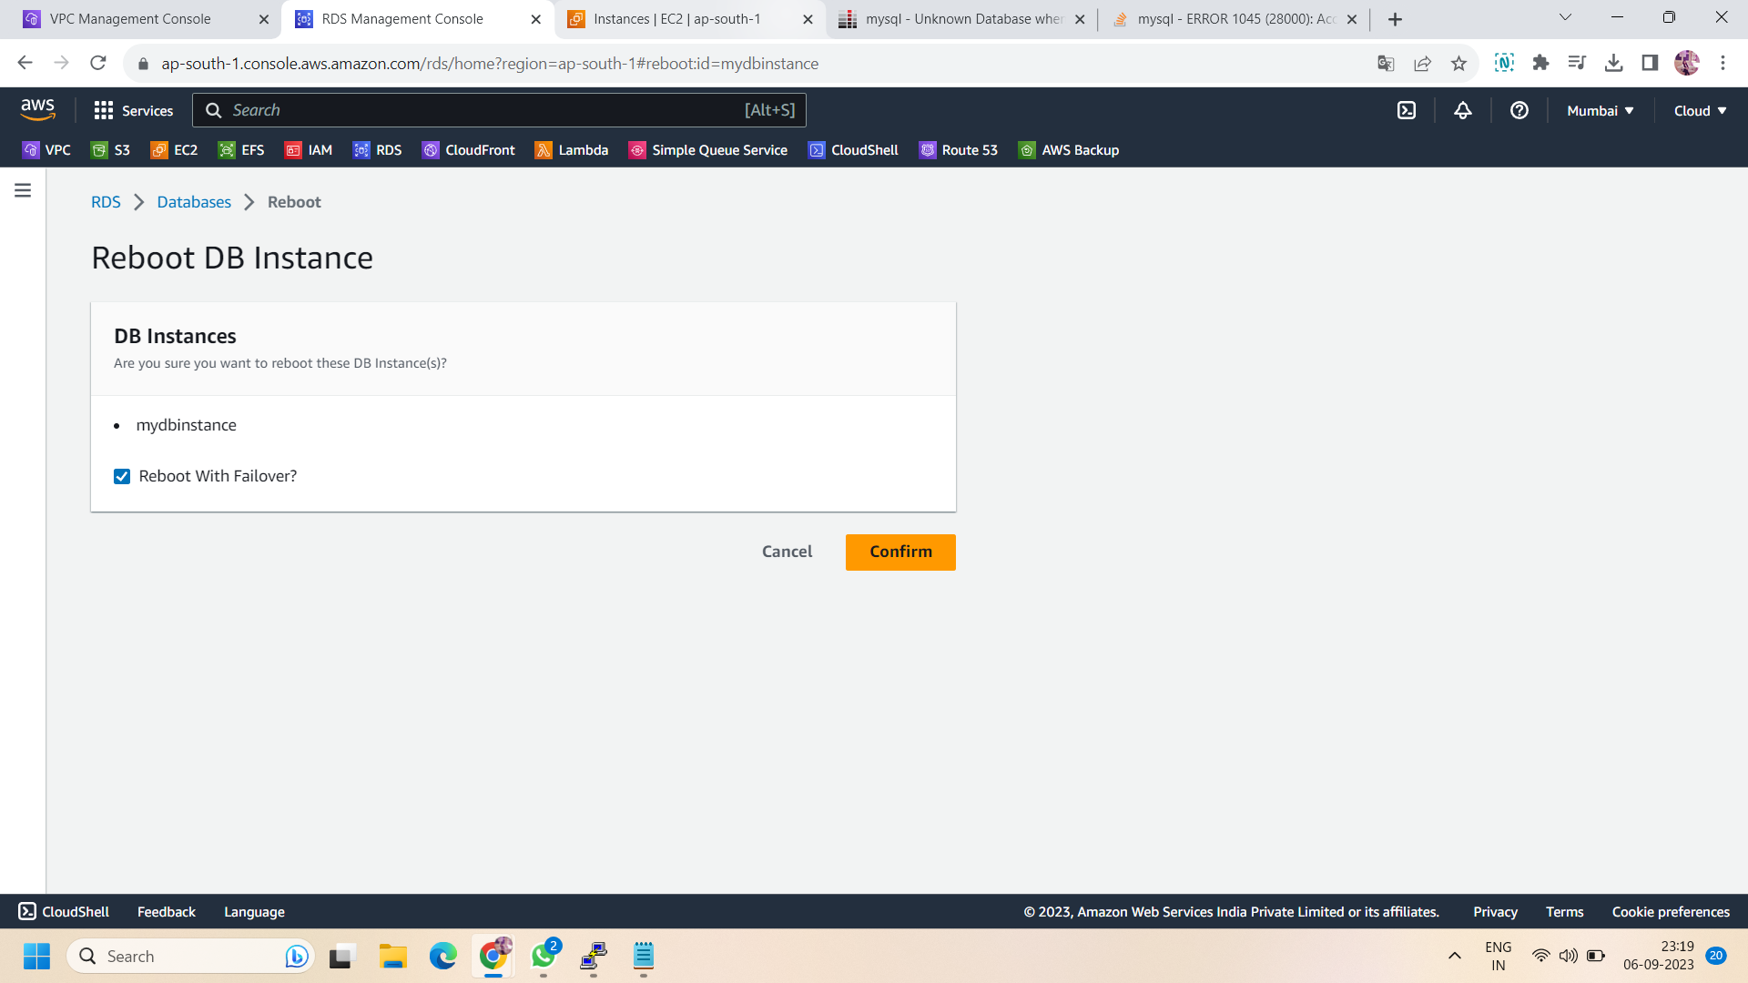

Step 15: You can check the log of it in “events” section of the RDS console.after reboot it will take time and automatically change its availability zone.

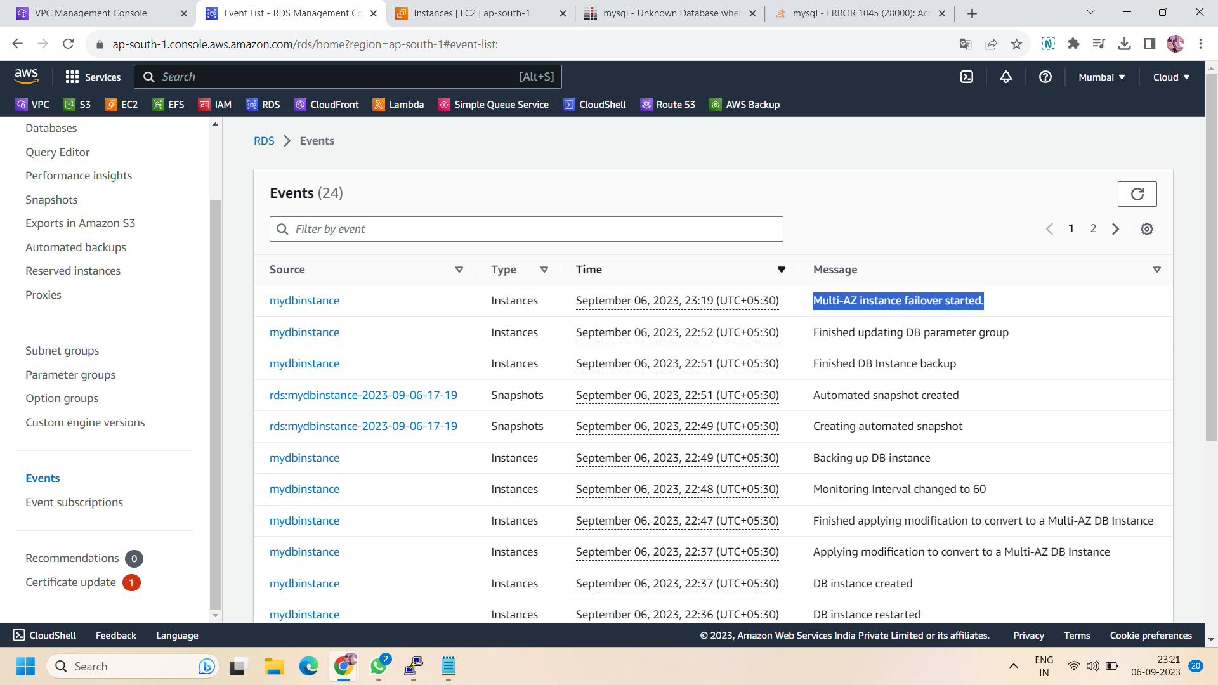

Step 16: Now go to your linux ,it will show you a different IP address of your standby private subnet.e.g.,earlier was 10.100.1.73 and after failover it is 10.100.2.73

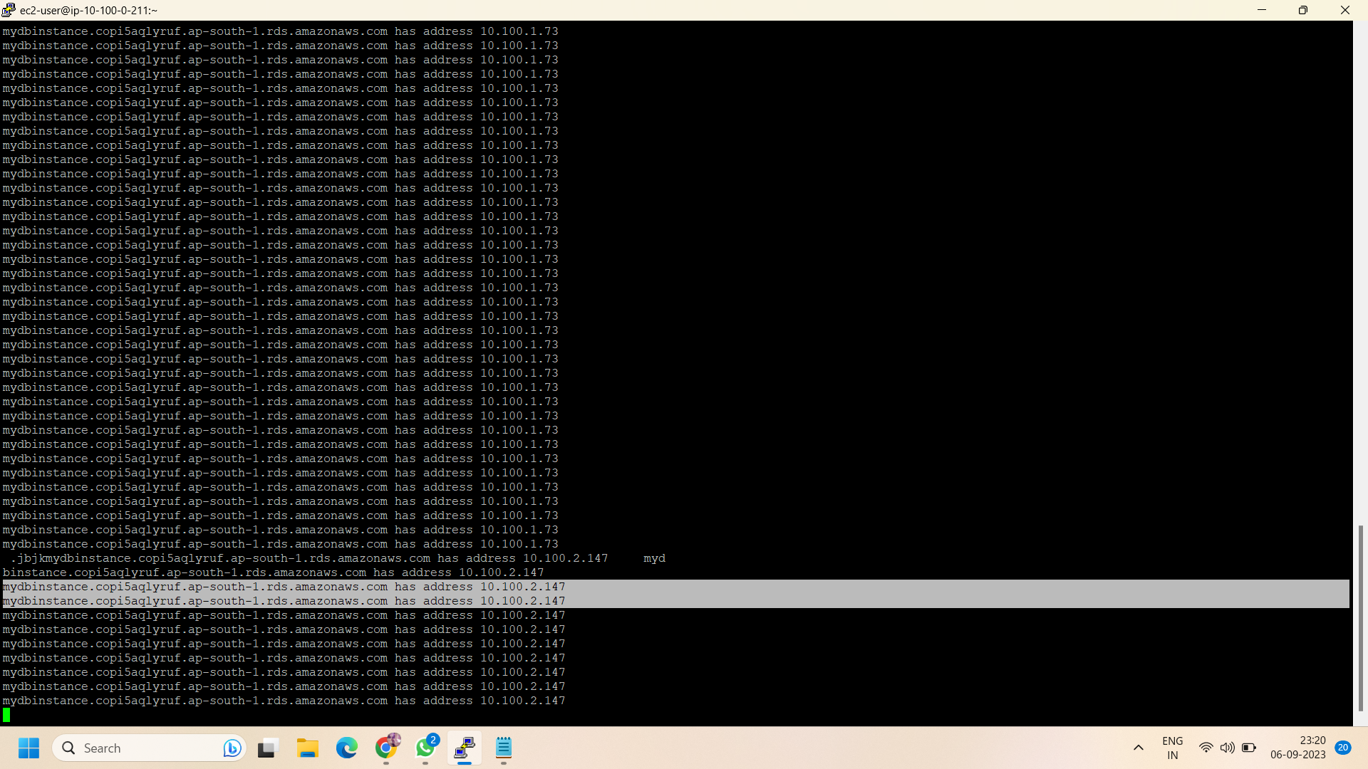

Step 17: now go to your RDS database and check its availability zone,it will be ap-south-1b” .

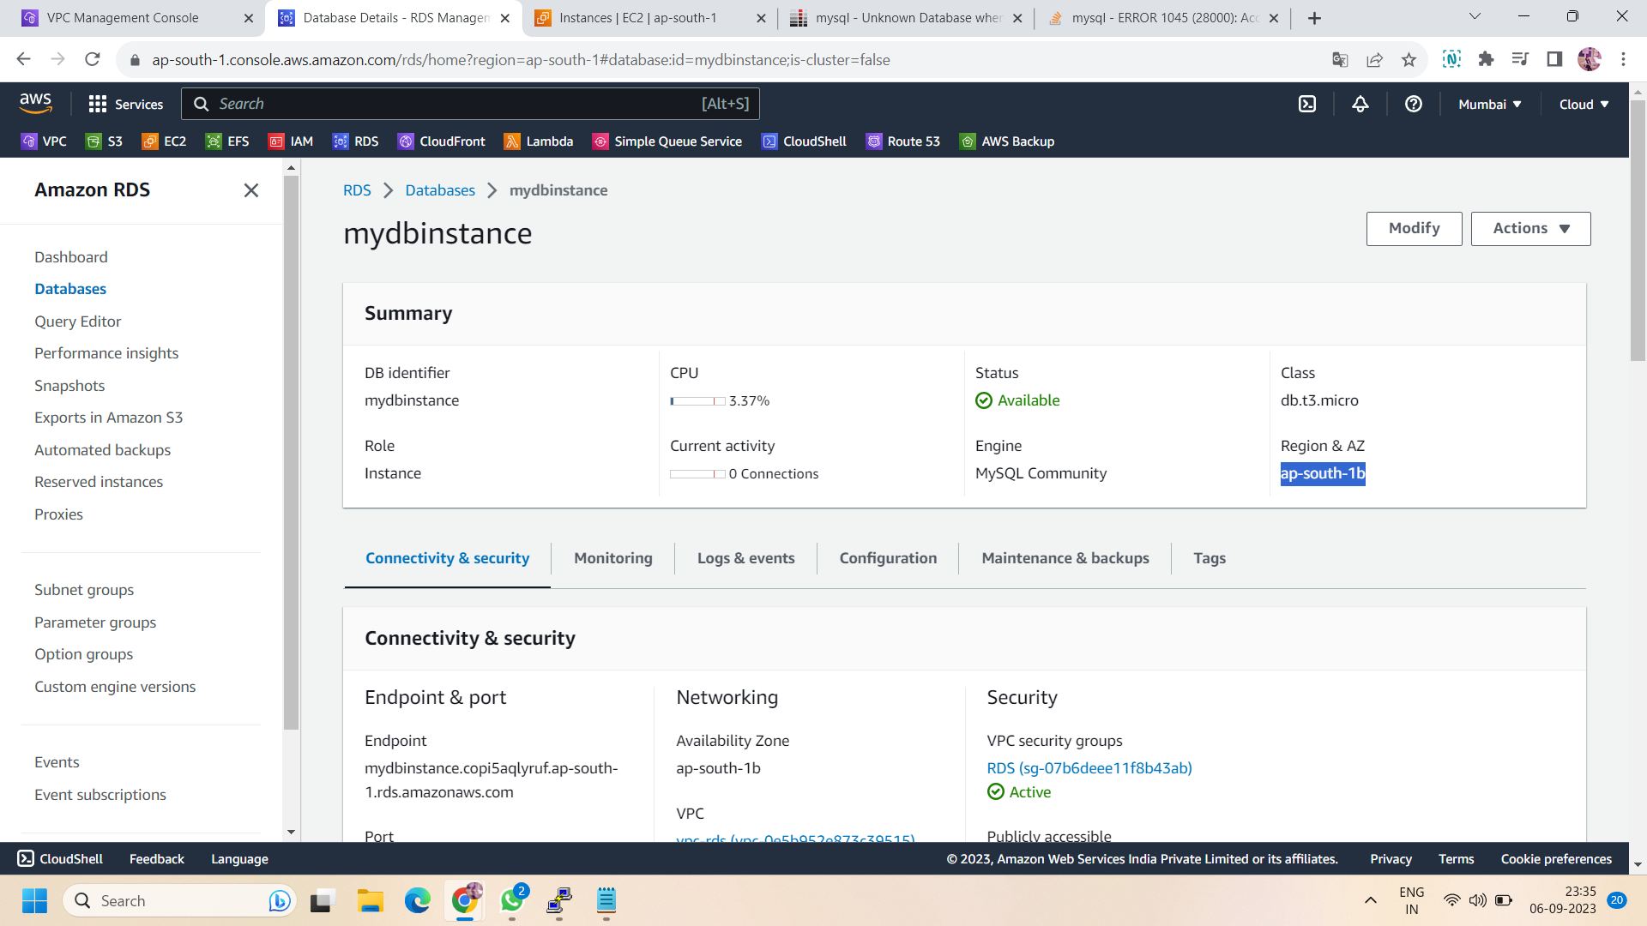

Step 18: this is how you can use the RDS multi-AZ failover.

ALL done!!